# Updating Rock Plugins to .NET 4.7.2

## Errors

If you haven’t updated your plugin projects to 4.7.2 yet, you’ll see errors/warnings if you attempt to build

* Error: The type of namespace name ‘Rock’ could not be found
* Warning: The referenced project 'Rock' is targeting a higher framework version (4.7.2) than this project’s current target framework version (4.5.2). This may lead to build failures if types from assemblies outside this project’s target framework are used by any project in the dependency chain.

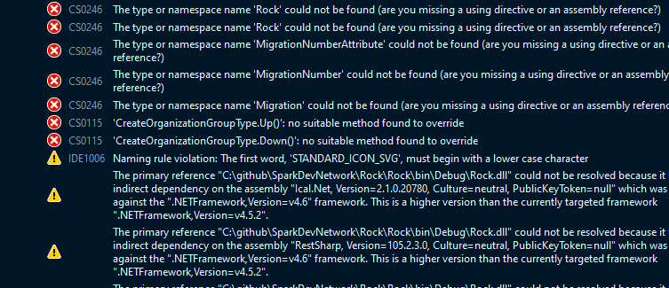

## How to update

Change Target framework to .NET Framework 4.7.2

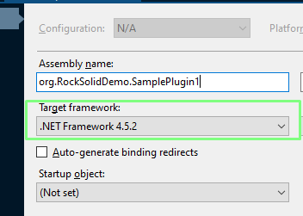

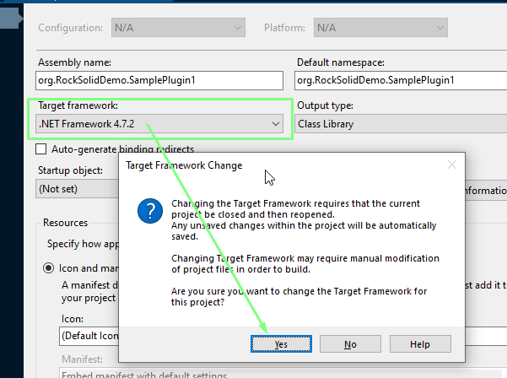

## If your project has NuGet packages

Go to Package Manager Console

PM> Update-Package -ProjectName MyProject -reinstall

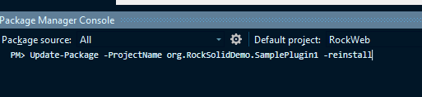

You’ll notice that the packages.config file changes the targetFramework for your packages to net472

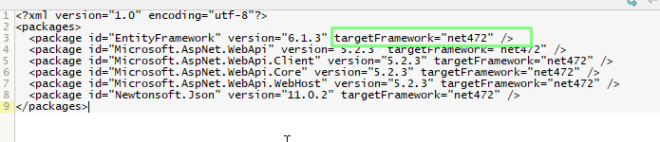

App.Config

You might notice changes to app.config. You’ll probably see that <supportedRuntime version="v4.0" sku=".NETFramework,Version=v4.7.2" /> was added. If so, keep that in there. If there are other changes, review those. It is possible that it made changes that weren’t needed. If you think some of the changes aren’t needed, you might be able to undo those without causing problems.

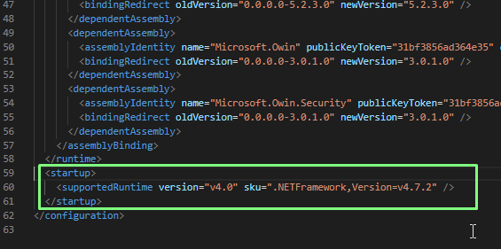

## Rebuild

1. Rebuild Solution.
2. It should succeed, but if not, fix issues

## Test

Run RockWeb and see if your plugin works